Task 01

TestJunit.java

import org.junit.Test;
import static org.junit.Assert.assertEquals;

public class TestJunit {
@Test
public void testSubtract() {
int num1 = 10;
int num2 = 5;
int res = num1 - num2;
assertEquals(5 , res);
}
}
TestRunner.java

import org.junit.runner.JUnitCore;
import org.junit.runner.Result;
import org.junit.runner.notification.Failure;

public class TestRunner {
public static void main(String[] args) {
Result resobj = JUnitCore.runClasses(TestJunit.class);
for (Failure fobj : resobj.getFailures()) {
Sout(fobj.toString());
}
sout(resobj.wasSuccessful()); //--> true
}
}

Task2. Test Suite:

- its a bundle of unit test cases and run them
all together.
@Suite
@RunWith

TestSuite Demo

import org.junit.runner.RunWith;
import org.junit.runners.Suite;

@RunWith(Suite.class)

@Suite.SuiteClasses( {
JunitTest01.class,
JunitTest02.class,
JunitTest03.class
})

public class TestSuiteDemo {

}

JunitTest01.java

import org,junit.Test;
import static org.junit.Assert.assetEquals;
import org.junit.Igore;
public class junitTest01 {

String msg = "running test01 ";

MessageUtil msgUtilobj = new MessageUtil(msg);
//MessageUtil is a utility class
//store a message
@Test
public void msgTest() {
sout("we are inside the msgtest()");

assertEquals(msg, msgUtilobj.printMessage());
}
}

junitTest02.java

test Runner

Home Tasks :
Task 01: List down the methods of Assertion class in Junit

assertEquals , assertTrue , assertFalse , assertNotEquals , assertNull
assertNotNull , assertSame , assertNotSame
assertArrayEquals , assertThrows , assertTimeout
Task 02:

Implement

assertNotSame
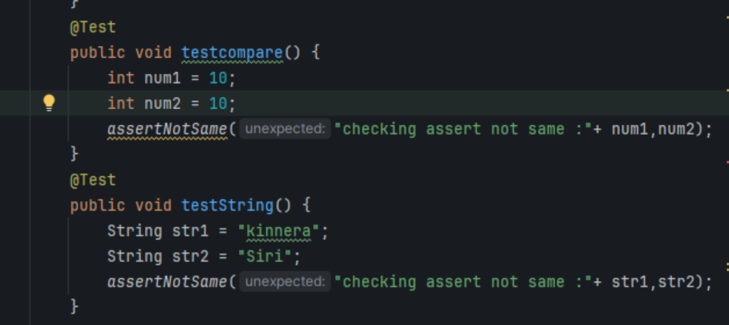

assetSame

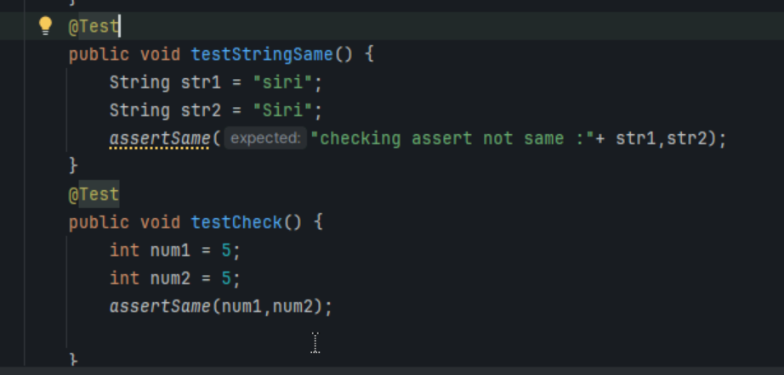

assertArrayEquals()

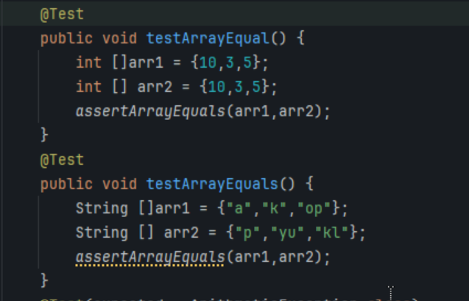

Methods in your codes..

Task 03:
Ignore Test
Add @Ignore to your one of the test case and check if thet case is ignored or not

Task 04: Time Test

In one the tests pass the timeout parameter with value and check if the test case fails if the time is out

@Test(timeout = 1000)
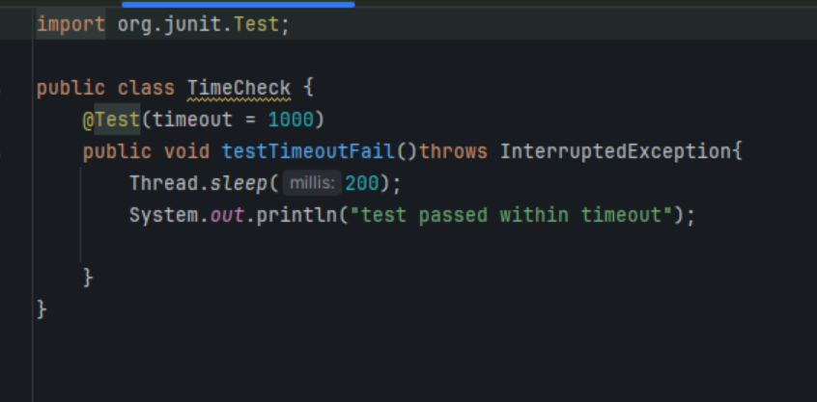

Task 05: Exception test

In one of your tests check for arithmetic exceptions and see if it works..

@Test(expected = ArithmeticException.class)
